Lab 2
Web programming

Name : umar ahad uddin ahmed usmani
Sap : 60199
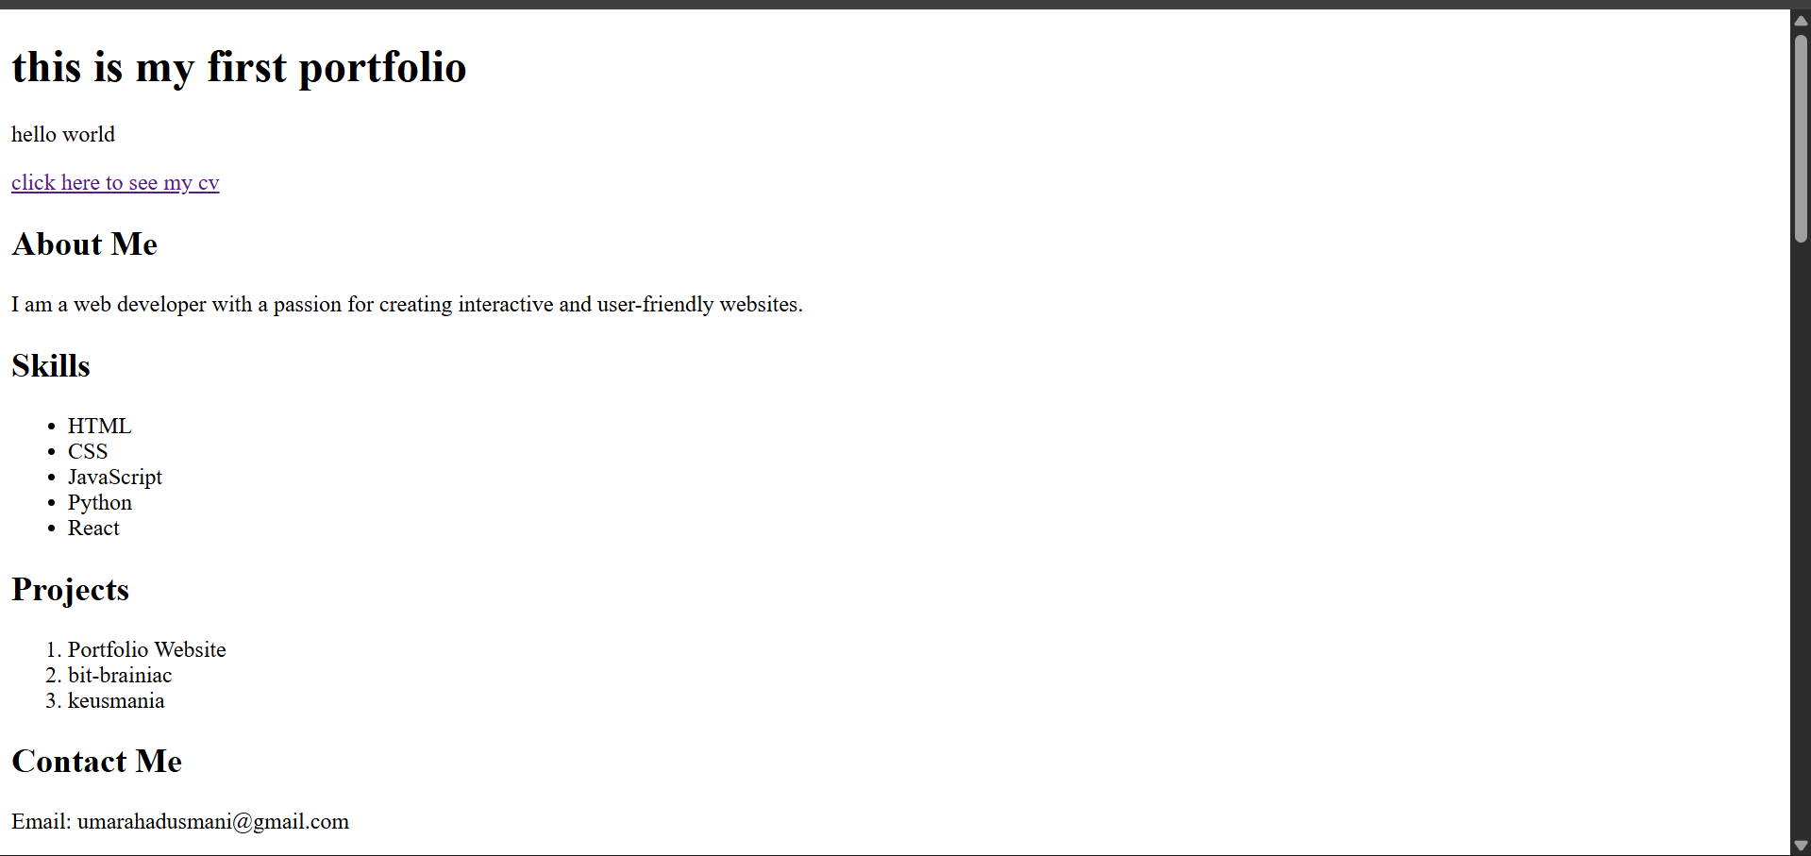

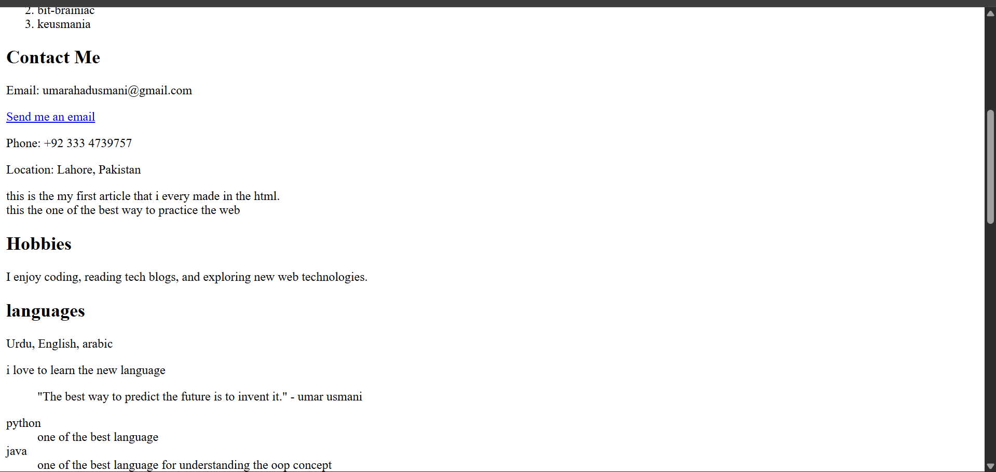

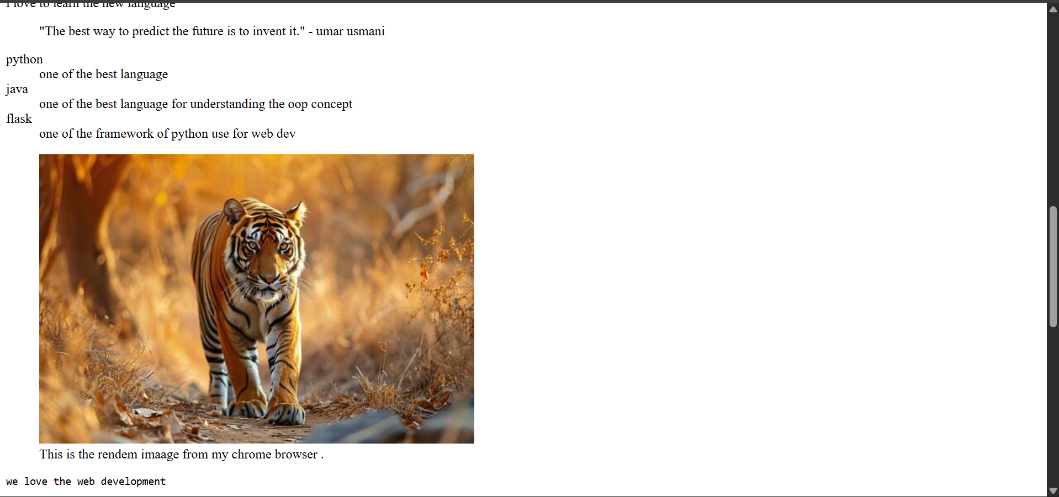

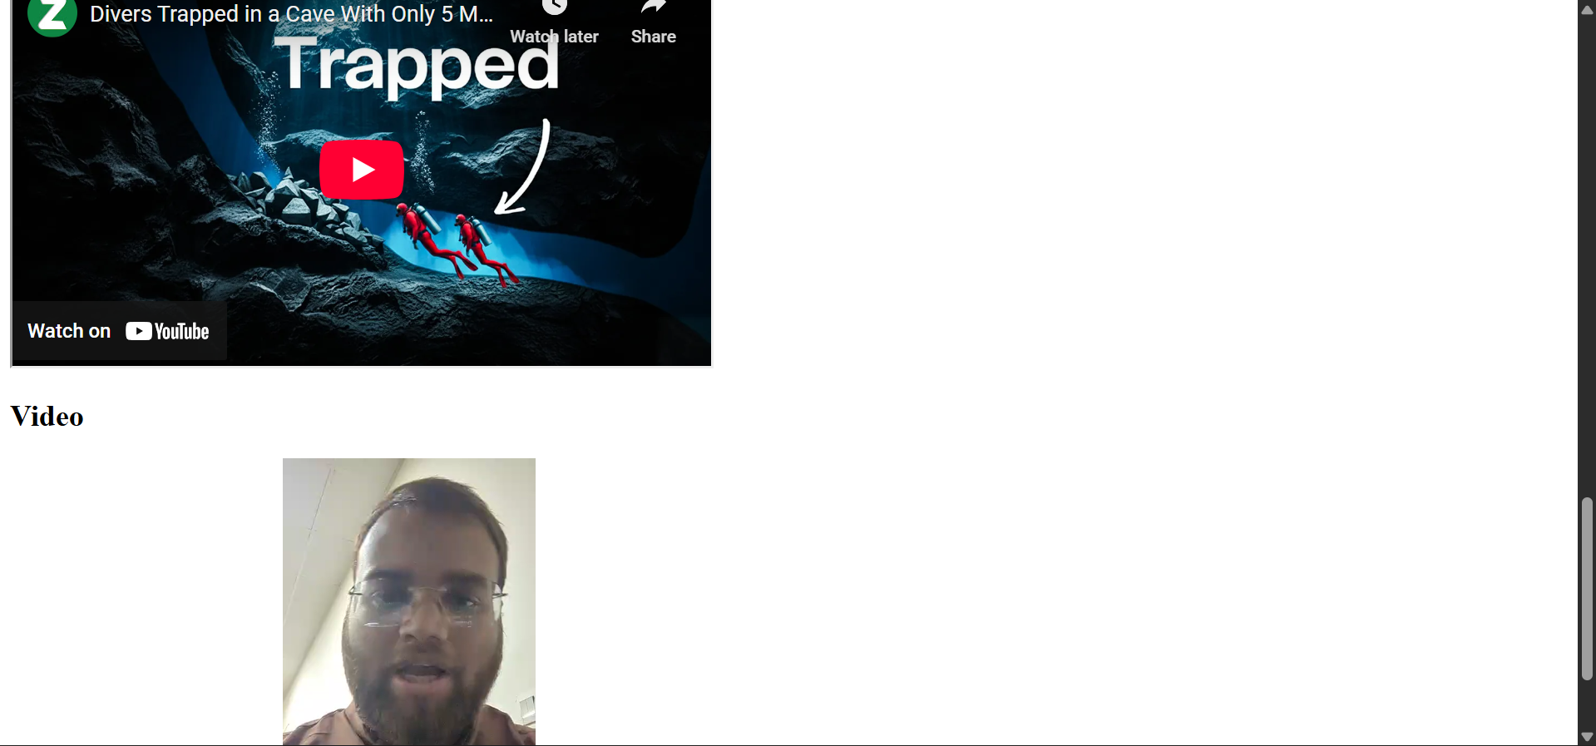

Here is the code of prctice :
<!DOCTYPE html>
<html lang="en">
<head>
<meta charset="UTF-8">
<meta name="viewport" content="width=device-width, initial-scale=1.0">
<title>this is my first portfolio</title>
</head>
<body>
<h1>this is my first portfolio</h1>
<p>hello world</p>
<a href="umar-ahad-usmani-cv.html">click here to see my cv</a>
<h2>About Me</h2>
<p>I am a web developer with a passion for creating interactive and user-friendly websites.</p>
<h2>Skills</h2>
<ul>
<li>HTML</li>
<li>CSS</li>
<li>JavaScript</li>
<li>Python</li>
<li>React</li>
</ul>
<h2>Projects</h2>
<ol>
<li>Portfolio Website</li>
<li>bit-brainiac</li>
<li>keusmania</li>
</ol>
<aside>
<h2>Contact Me</h2>
<p>Email: umarahadusmani@gmail.com</p>
<a href="mailto:umarahadusmani@gmail.com">Send me an email</a>
<p>Phone: +92 333 4739757 </p>
<p>Location: Lahore, Pakistan</p>
</aside>
<article>this is the my first article that i every made in the html. <br>
this the one of the best way to practice the web </article>
<section>
<h2>Hobbies</h2>
<p>I enjoy coding, reading tech blogs, and exploring new web technologies.</p>
<h2>languages</h2>
<p>Urdu, English, arabic </p>
<article>i love to learn the new language </article>

</section>
<blockquote>
<p>"The best way to predict the future is to invent it." - umar usmani</p>
</blockquote>
<dl>
<dt>python</dt>
<dd>one of the best language </dd>
<dt>java </dt>
<dd>one of the best language for understanding the oop concept </dd>
<dt>flask</dt>
<dd>one of the framework of python use for web dev </dd>
</dl>
<figure>
<img src="https://static.vecteezy.com/system/resources/thumbnails/036/324/708/small/ai-generated-picture-of-a-tiger-walking-in-the-forest-photo.jpg" alt="Placeholder Image">
<figcaption>This is the rendem imaage from my chrome browser .</figcaption>

</figure>
<pre>we love the web development</pre>
<iframe width="560" height="315"
src="https://www.youtube.com/embed/elmmsJquj_w"
title="YouTube video player"
></iframe>
<h2>Video</h2>
<video controls width="640" height="360">
<source src="ai.mp4" type="video/mp4">
</video>

</body>
</html>

